**SALESFORCE PROJECT**

**MILKEASE**

* **Phase 7:   Integration & External Access.**

👉 Goal **: Connect with outside systems.**

* **Named Credentials**:-
* Store API credentials securely.

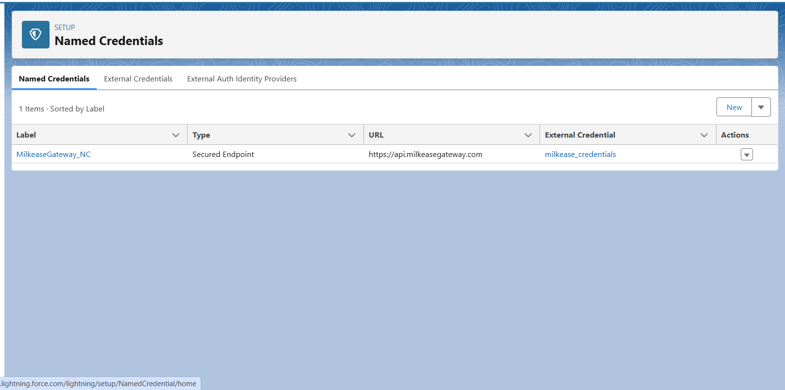

* **External Credential**:-
* Store Externel credentials securely.

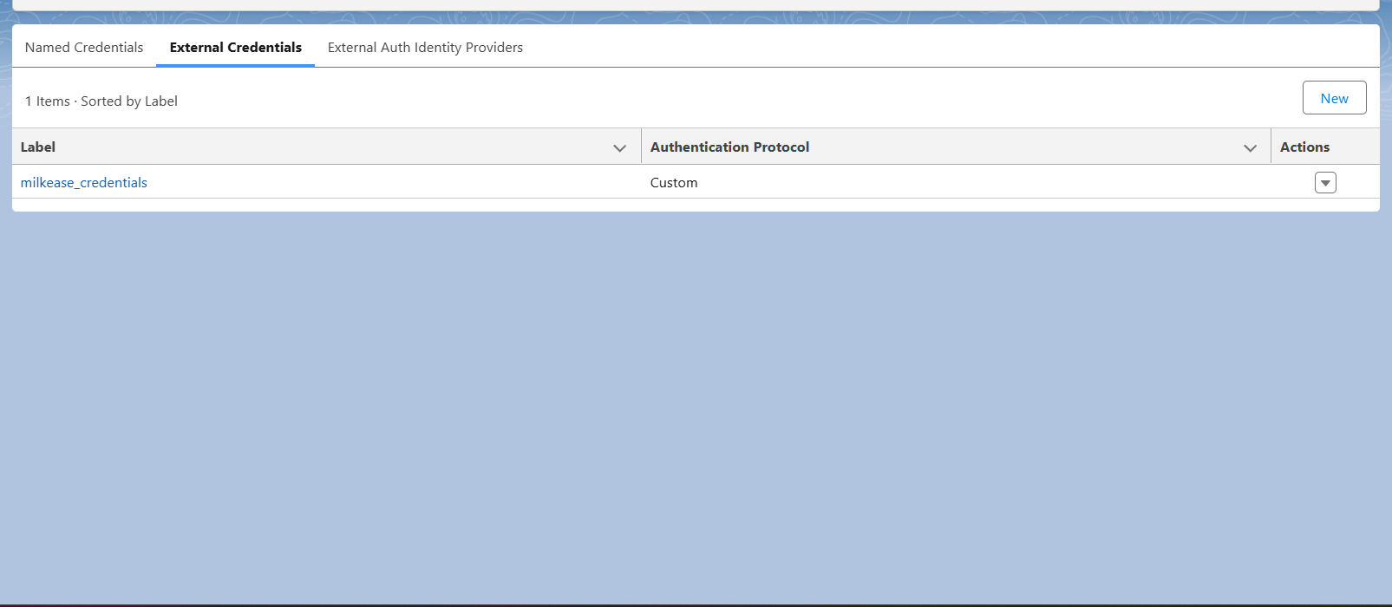

* **REST Callouts**:-
* Trigger from Delivery Booking creation safely.

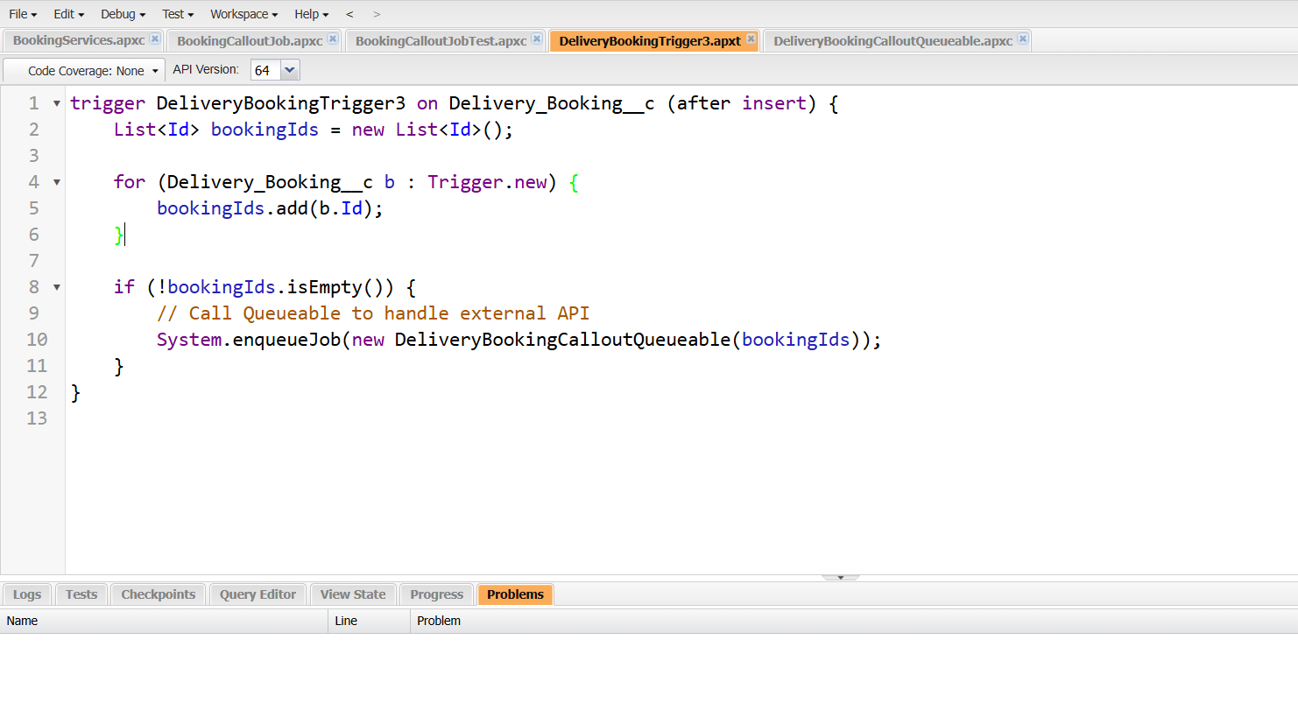

* **Callouts Test**:-
* Delivery Booking callout Job Test in apex.

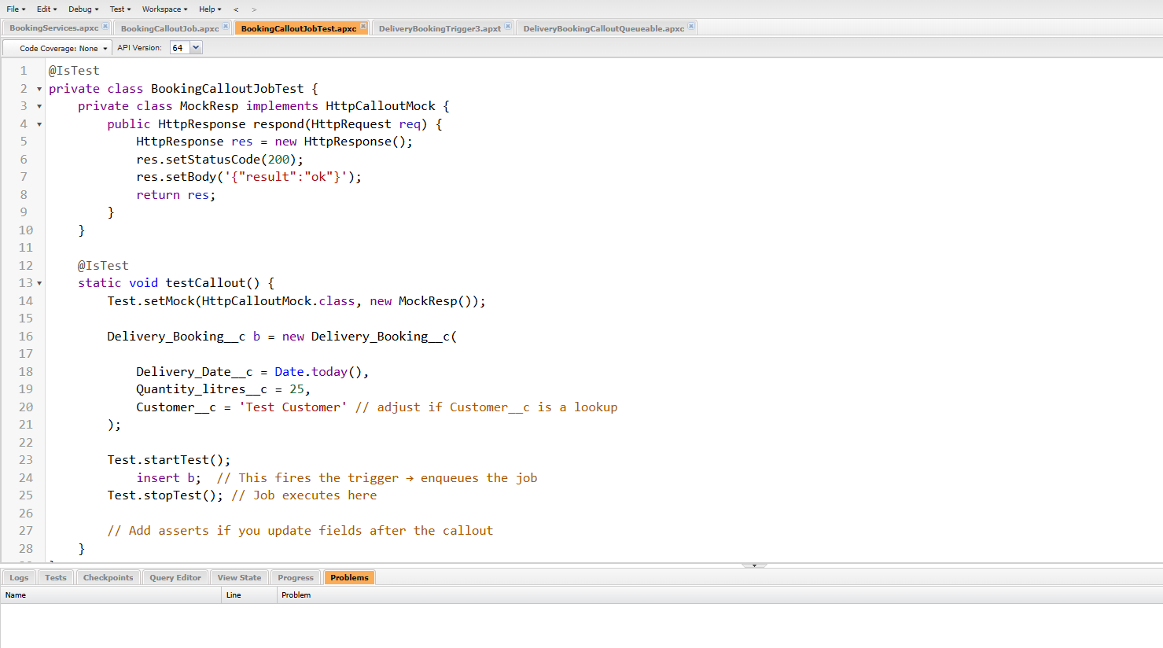

* **Queueable Callouts**:-
* Delivery Booking Queueable Callout.

